**FULL SUBTRACTOR USING LOGISIM**

AIM:

To design and implement the full subtractor using Logisim simulator.

PROCEDURE:

1) Pick and place the necessary gates.

2) Insert 3 inputs into the canvas.

3) Connect the inputs to the XOR gate, AND gate and OR gate.

4) Insert 2 outputs into the canvas.

5) Make the connections using the connecting wires.

6) Verify the truth table.

TRUTH TABLE:

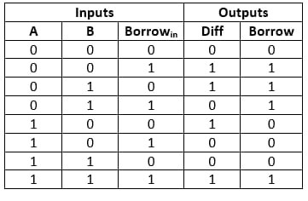

Diff=(A ⊕ B) ⊕ 'Borrowin'

Borrow=A'.B + (A ⊕ B)'

OUTPUT:

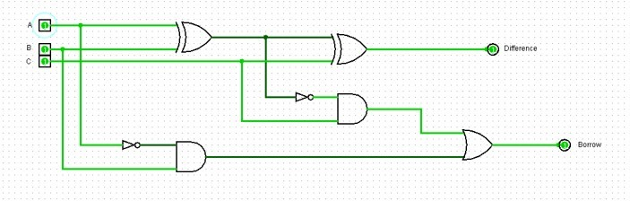

RESULT: Thus full subtractor has been designed and implemented successfully using logisim simulator.